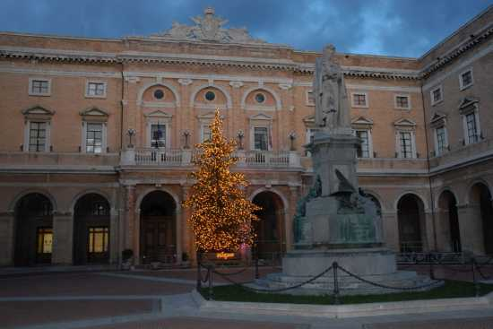

CIRCOLO DIDATTICO VIALE CESARE BATTISTI – 62019 RECANATI - ITALY
Protocol from the meeting with the coordinators, headmasters, other teachers and the students participating in the visit in RECANATI during the period 07.04.2011-13.04.2011 according to the plan of the project
“Towards a greener future”
TEACHERS PARTICIPATING IN THE MEETING:
JOLANTA BEDNAREK | PROJECT ‘S COORDINATOR  FROM POLAND
ANNA KRASOWSKA | POLAND
IRENA MENDYK0WSKA | POLAND
SONJA ZAGAR | SLOVENIA
TAJA BUCAR | SLOVENIA
JUDIT TERUEL | COORDINATOR FROM SPAIN
ANNA PASCUAL | SPAIN
NIKOLAOS MOISOGLOU | COORDINATOR FROM GREECE
ZOI SARIVASILEIOU | GREECE
MARIE-YVONNE LE HELLAY | COORDINATOR FROM FRANCE
NATHALIE PERRON | FRANCE
NATHALIE GUERNEVEL | FRANCE
ALINA LOREDANA MOCANU | COORDINATOR FROM ROMANIA
TRAIANA MIORIŢA OLEA | ROMANIA
MARTA ANA LOBONŢIU | ROMANIA
FLOARE IEDERAN | ROMANIA

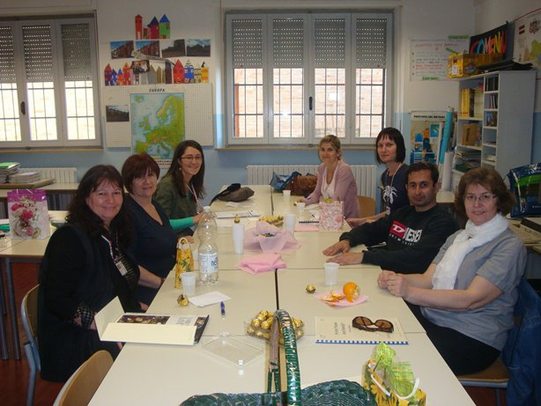

STUDENTS PARTICIPATING IN THE MEETING:
Paweł Nawrat | POLAND
Kamil Żukowski | POLAND
Szymon Babula | POLAND
Wiktoria Jasińska | POLAND
Natalia Wyleżoł | POLAND
Paul Bellon | FRANCE
Théo Regardin | FRANCE
Aurore Pavic | FRANCE
Edern Mathonnet | FRANCE
Paul Le Gal | FRANCE
Aymeric STEINMETZ | FRANCE
Arnaud Cheridi | FRANCE
Ayad Saidani | FRANCE
Enzo Le Fée | FRANCE
Antoine Le Guennec | FRANCE
Mickaël Palabre | FRANCE
MARC NIETO | SPAIN
JOAN MARIA SOLDEVILA | SPAIN
ALEX SABATE | SPAIN
ALBA MORENO | SPAIN
LAIA MORENO | SPAIN
Veronika Magister | SLOVENIA
Anamarija Žnidaršič | SLOVENIA
Matevž Gros | SLOVENIA
Rok Korelc | SLOVENIA
Tara Rolih | SLOVENIA
TEODORA GEORGIANA RACOLŢA | ROMANIA
ERIK GEIGER | ROMANIA
DAIANA MARIA DRAGOS | ROMANIA
TEODORA MARIA CRISTEA | ROMANIA
MARCK SERBAN PERENI | ROMANIA
PAUL MACEC | ROMANIA

Proceedings:
-Planning the next project meetings in Greece and Slovenia;
-Discussing the question of the final products which need to be accomplished within the next two months of the project work ;
-Exchanging information about the way the planned activities have been completed according the partnership’s calendar activities;
-Establishing further steps each school will take for accomplishment of the activities;
-The final products : a report of the survey ‘Is your home eco-friendly’
Activities:
During the meeting the participants had the opportunity:
- to find out about the Italian education system, teaching methods and aids applied by teachers;
-to participate in the following activities:
Preprimary, Primary and Hospitality High Schools visits
Students songs performance
“Make a pizza” – workshops;
Artistic works of recycled material;
Meeting with the Mayor of Recanati.
English guides on the environment
Visit to the environmental center of Recanati,
Visit Loreto city, the place of catholic importance;
Visit to the Conero Park

