

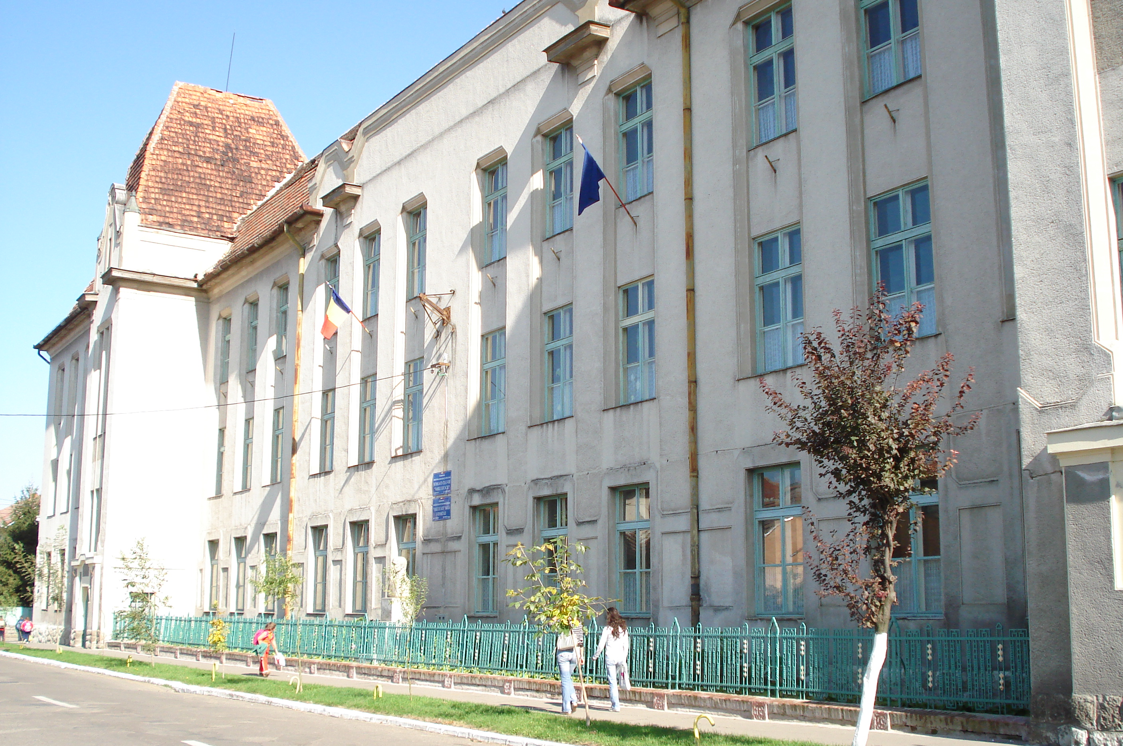



Şcoala cu clasele I-VIII
„Vasile Lucaciu” Carei
Str. Vasile Lucaciu Nr. 16
http://vasilelucaciucarei.wordpress.com
e-mail: scoalavasilelucaciu@yahoo.com
tel/fax 0261861186

LESSON PLAN

Topic: The conservation of renewable resources
Lesson type: information transmission and acquisition
Motivation: This lesson analyses the importance of water and other natural resources that are important for the preservation of the characteristics of the environment

OBJECTIVES:
a) Cognitive:
- to identify the main natural resources of the Earth, i.e. the renewable resources;
- to select pieces of information according to certain criteria and put them in order;
- to identify sources of water pollution and water pollutants;
- to imagine and list measures of water protection and treatment.

b) Methodological:
- to recognize the importance of water and other natural resources, which are also known as renewable resources;
-to structure pieces of information into clusters;
- to structure pieces of information into logical diagrams.

c) Attitudinal:
- to learn trough cooperation with colleagues;
- to ask colleagues questions in a civilized manner;
- to properly assess the colleagues’ answers;
- to assume personal and group responsibility;
- to perform the workload during a given time span.

Prior conditions: students have prior knowledge on the natural resources.
Material resources: .ppt format pictures and information, magazines, students’ books, worksheets.
Teaching techniques: conversation, demonstration, analysis, observation, cluster.
Forms of organization: frontal, groups, individual.

LESSONS STAGES

Activity 1:
The lesson starts with watching the power point presentation. This presentation contains the renewable resources that can be found in Romania. The teacher explains one by one the importance of each resource found in Romania and, meanwhile, the students may ask questions concerning these resources if they are unfamiliar with them.

Activity 2:
After watching the presentation and from their general knowledge, the students will fill out the following table:

SOURCES OF POLLUTION | POLLUTANTS
Industrial areas
Agriculture
Transportation facilities
Houses

The table will be filled out as follows:

SOURCES OF POLLUTION | POLLUTANTS
Industrial areas | Bacteria from slaughterhouses, hydrocarbon, dust from waste dumps, various chemicals
Agriculture | Pesticides, chemical fertilizers, organic matter
Transportation facilities | Hydrocarbon
Houses | Detergents, organic matter, fat (burnt oil)

Activity 3:
The students are divided into three groups. Each group receives a note with one of the following requirements:
a) List four measures to prevent pollution by involving the authorities
b) List four measures to reduce water pollution by involving the authorities
c) List four measures to reduce polluting through personal involvement

The answers are written on a white sheet of paper, which later will be displayed in front of the class.

Possible answers from the group activities are:

a) Measures to prevent pollution by involving the authorities:
-setting up special areas for the storage of wastes
- prohibiting the disposal of wastes in the water
- giving fines
- creating a system for collecting and sorting wastes
- having campaigns to promote the environment-friendly products

b) Measures to reduce water pollution by involving the authorities
- using special equipment to collect wastes from the water
- educating the communities
- changing the mentality (”Flowing water carries the wastes to other places”; “If there already are wastes here, why shouldn’t I throw mine here as well?”) and habits of our peers (“throwing wastes randomly”)

c) Measures to reduce polluting through personal involvement
- not to throw wastes in water
- using natural products in domestic activities
- reducing the consumption of cosmetics and polluting detergents
- burning of wastes
- using environment-friendly transportation facilities
- involving ourselves in the education of others
- the power of the personal example
- founding ecological associations

Activity 4:
If there is still time, the following website will be opened: http://video.google.com/videoplay?docid=3930199780455728313#docid=-8915966819502040048
If there is no more time left, this activity can be assigned as homework.

Activity 5:
Assigning homework:
The students will have to draw up a cluster that will emphasize “The importance of the atmosphere”

Example:

Carbon dioxide

The importance of the athmosphere
Vital gases
Radiation filter
………..
………
Sound transmission
Oxigen

