

Worksheet A - Picture cards
Daily activities with water

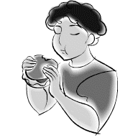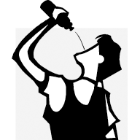
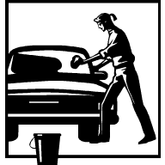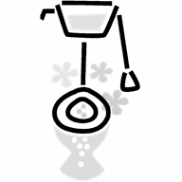
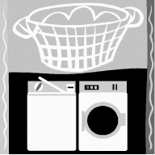

Worksheet b - 9 ways to save water
Complete the following sentences using should or shouldn’t.

1.When you wash the car, you _________ use a bucket, you
_____________ use the hose.

2.When you have a shower, you __________ keep the water on low
power and do not stay for more than 5 minutes.

3.You __________ collect rain water in a large bucket to water the
garden.

4.To save water, you ____________ put a bottle of water or sand in the
toilet cistern.

5.You ___________ put litter in the toilet.

6.When you brush your teeth you ___________ use a glass of water
instead of keeping the tap on.

7.You ______________ refill your water bottle with tap or filtered water
instead of buying a new bottle of mineral water.

8.You ______________ only use the washing machine when it’s full.

9.You _____________ reuse water from the house to water plants. Dish
water or water from your fish bowl is very good for plants.

