Park of Surprises in Ustroń

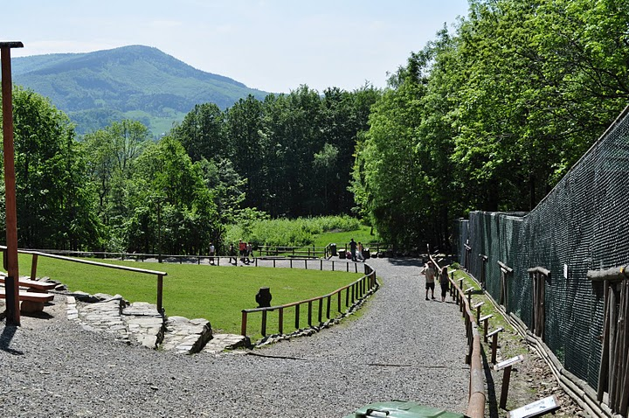

History
The park was opened on 1st August 2002. It is situated in Zawodzie Ustroń, in Silesian Beskid. It takes the area of 15 hectares and it offers over 3.5 km of paths prepared for visitors. The park has picturesque spa surroundings being full of tourist attractions.
The park which is an untypical zoological garden, undoubtedly belongs to the most interesting places of this kind. It is located on the area extending on the south slope of Równica, whose natural part remains under the rigorous protection. The park was created not only because of recreational purpose, but also as part of education of children and young people.

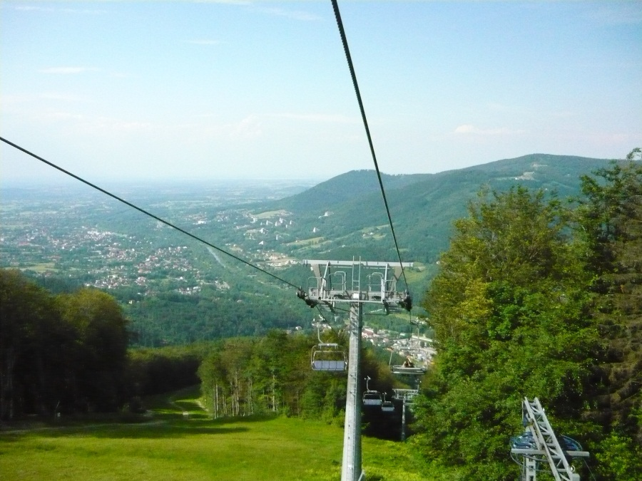

What can you see in the Park of Surprises?
You can admire, feed and stroke animals.
You can watch the following species: European bisons, deers, moufflons, wild boars, wild cats, ferrets, goats, rabbits.
In the park there is also a place where you admire beautiful eagles, falcons, hawks, buzzards and owls.
There is also a museum where you can be familiarised with numerous exhibits and hunting trophies.
If you are more interested in hunting you can watch a film giving away the secrets of this activity.
The park provides visitors with the possibility of resting and tasting delicious homemade dishes and warm and cold drinks.
As for the youngest guests, it offers a recreational complex including a playground, a fairy-tale avenue with a movable exhibition, a clearing perfect for having picnics and spots where you can admire amazing views.

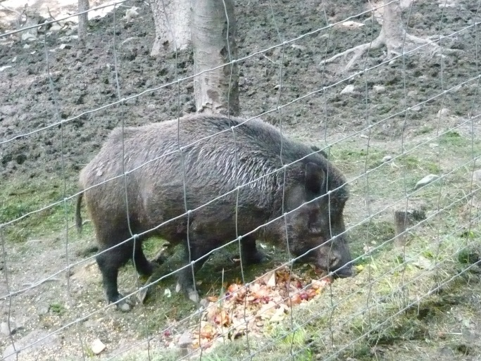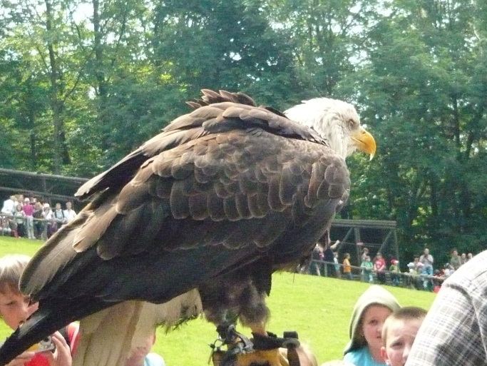

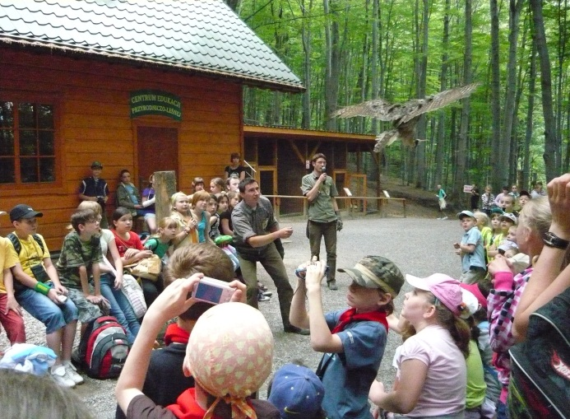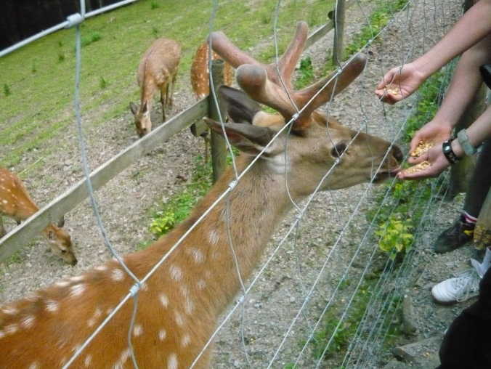

OPENINIG HOURS:
- April-October: 9.00-18.00
- November-march: 10.00-16.00
PRICES OF THE TICKETS:
- Adults: 19zl
- Children and youth: 15 zl
- Pensioners: 15 zl
- Groups : children 11 zl, adults 16zl
CONTACT:
The Park of Surprises
Zdrojowa Street 16
43-450 Ustroń
+48 515 255 161

