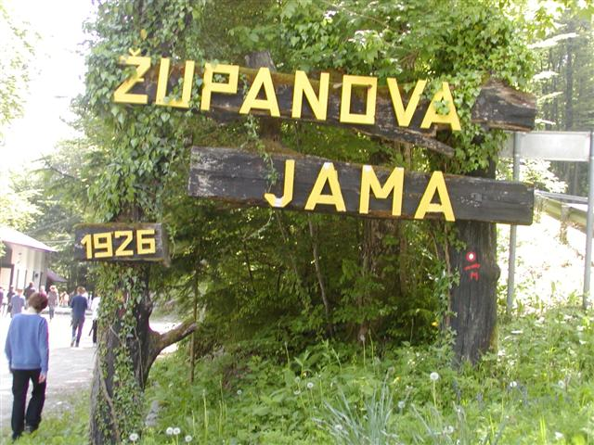
ŽUPANOVA JAMA

Županova jama je kraška jama, ki leži na nadmorski višini 410 m, dolga je 710 m ter doseže globino 77 m.

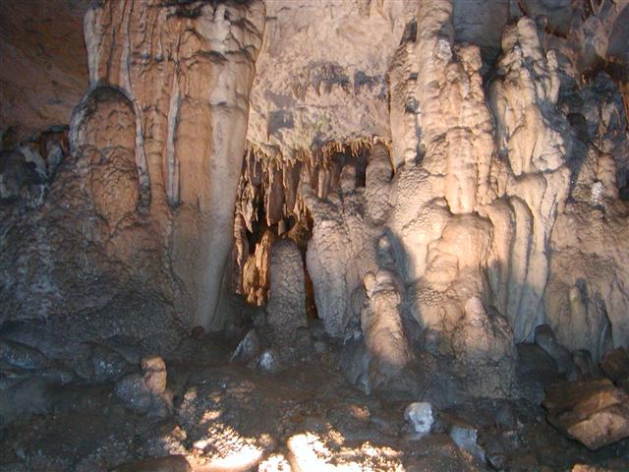
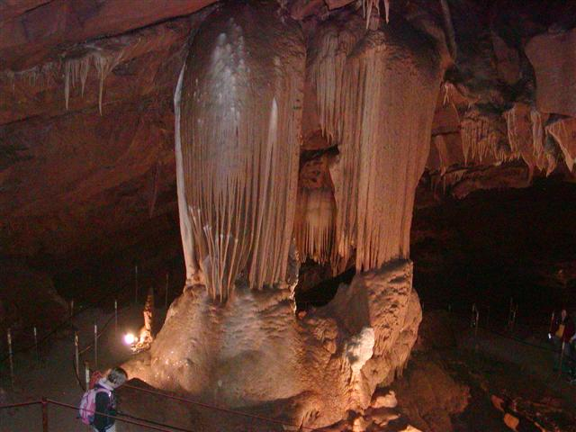
Ime je dobila po županu Josipu Permetu, ki je jamo odkril 26. maja 1926. Jamo sestavlja več dvoran. V njih najdemo skoraj vse značilnosti tipične kraške jame: stalaktite, stalagmite vseh oblik, barv in velikosti, brezna, jaške, sigaste ponvice. Živali v jami so prilagojene na podzemno življenje. Vhod v jamo je skozi Ledenico, ki je kakih 100 m od nekdanjega vhoda. Naslednja je Srebrna dvorana, za njo pa je Županova dvorana, ki je visoka 11 metrov in v njo je bil narejen prvi vhod. Nadaljuje se v rov , ki pelje v največjo dvorano v jami. V njej se nahajajo največji kapniki. Po ozkem rovu vodi pot do Blatne dvorane, ki je ime dobila po debeli plasti ilovice, ki je nekoč prekrivala tla te dvorane. Tudi v tej dvorani je nekaj mogočnih kapnikov. Do leta 1937 je veljalo prepričanje, da jama sega le do tod, nato pa so odkrili prehod skozi razpoke v steni. Preko tega prehoda vodi rov do Matjaževe dvorane, ki je ime dobila po legendi o kralju Matjažu. Dvorana se nadaljuje v krajši rov, ki se nato razširi v dvorano z imenom Zadnja dvorana. Ta dvorana se zaključi z globokim breznom, ki je bilo neraziskano do leta 1994. V tem letu so jamarji odkrili nadaljevanje jame in našli še eno dvorano, ki je dobila ime po odkritelju in se danes imenuje Igorjeva dvorana. 30 metrov dolga dvorana je dostopna le opremljenim jamarjem.

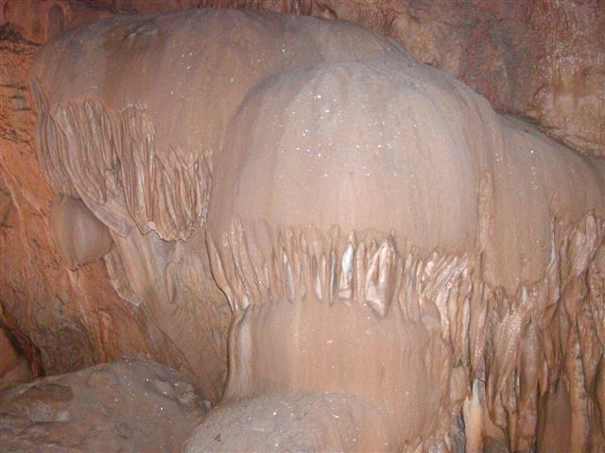
Jama je odprta od maja do septembra ob sobotah, nedeljah in praznikih ob 15. uri. Marca, aprila, oktobra in novembra pa le ob nedeljah in praznikih ob 15. uri. Možni so tudi ogledi po dogovoru.

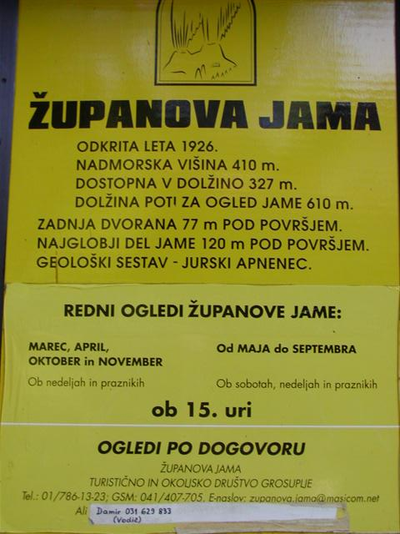
Vstopnina za v Županovo jamo za odrasle je 7 EUR, za otroke pa 5 EUR. Spletna stran je www.zupanovajama.si.

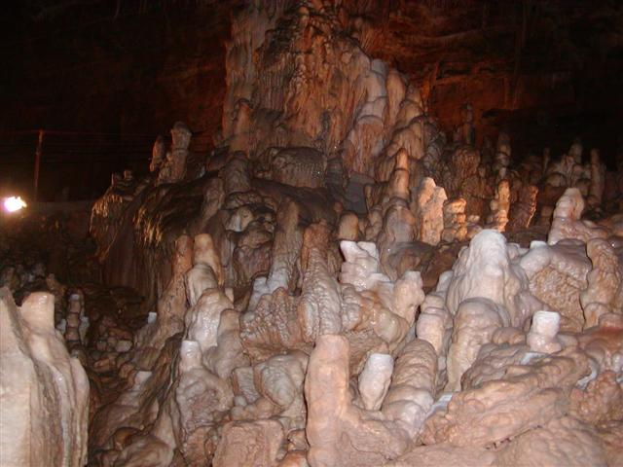

ŽUPANOVA JAMA – THE MAYOR'S CAVE

Županova jama is a karst cave, situated at an altitude of 410 m. It is 710 m long and 77 m deep.
It was named after mayor Josip Perme, who discovered the cave on 26th May 1926.
The cave is made up of seven beautiful halls, connected by 600 metres of walkway. In the Mayor’s Cave we can find almost all features, typical of Karst caves: stalactites and stalagmites of all shapes, colours and sizes, chasms, precipices, shafts, shallow sinter pools with crystal clear water and, in winter, ice stalactites in Ledenica. The animal life in the cave, adapted to living underground, is also very interesting. The entrance to the cave is through the chasm Ledenica which is about 100 metres from the original entrance. Next is the Silver Hall, followed by the Mayor's Hall, where the first entrance into the cave was made. The next hall is the biggest with the largest cave formations (speleothems). A narrow tunnel leads to the Muddy Hall, named for the cave clay, which once covered the ground in it. Here, too, you can see some impressive speleothems. In 1937 some cracks in the wall revealed a passage. This passage leads to another chamber, which was named Matjaž's Hall as the huge flowstone pillars look like Matjaž's throne from a local legend. From this hall you enter a short tunnel, which widens into the Last Hall. This hall ends in a deep pit, which was unexplored until 1994. In 1994 the speleologists discovered another chamber, which was named after the man who found it-Igor's Hall. The 30 m long chamber can be entered by adequately equipped speleologists only.
The cave is opened from May to the end of September on Saturdays, Sundays and holidays. The tour starts at 3.00 pm. In March, April, October and November, the cave is opened only on Sundays and holidays. Group tours can be arranged beforehand on other days of the week as well. The tour lasts about an hour. More information is available on www.zupanovajama.si (unfortunately only in Slovenian language, but you can see some beautiful pictures of the cave) and on the telephone number +386 41 407 705.
The entrance fee is 7 Eur for adults and 5 Eur for children.

